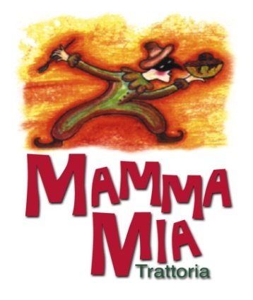
Four Course Menu

APPETIZERS
Arancini, risotto with mixed cheese
Fried Provolone cheese
Mamma’s mixed baby organic greens, with candied walnuts, cherry tomatoes and dried cranberries topped with goat cheese and tossed in a raspberry vinaigrette
Lumache di mamma, in a marinara sauce
Beef Carpaccio, topped with Parmigiano shavings, and baby greens
Entrée
Cheese filled Tortellini with veal, peas and mushrooms in a cream sauce
Fusilli with Sicilian olives, artichokes, and roasted red peppers in a white wine, olive oil and garlic sauce
Wood oven pizza with pesto sauce, grilled zucchini and eggplant, roasted red peppers, and mushrooms, mozzarella and asiago cheese
Wood oven pizza with tomato sauce, sopressata, pepperoni, bacon, Italian sausage, mozzarella and asiago cheese
Wild Alaskan pacific cod, Parmigiano cheese crusted with a lemon white wine sauce
Roman Roasted Salmon
Chicken or Veal breaded and topped with a gorgonzola cheese, mushroom & white wine sauce
Desserts
Mamma’s apple and dulce di leche cheesecake
Chocolate brownie napoleon
Freshly baked apple turnover with vanilla ice cream
Crème Brule

$65 per Person
(Includes a glass of wine, excluding taxes and gratuities)

