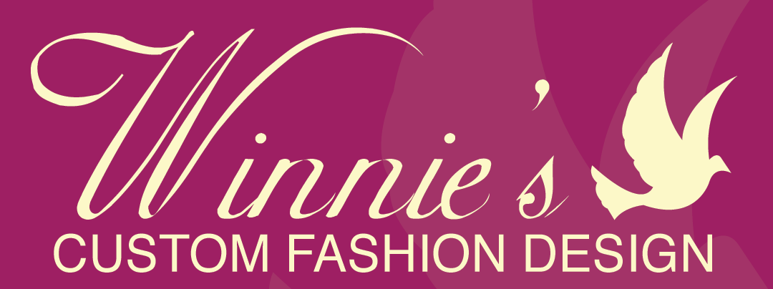
Georgia, Atlanta - Colony Square
1201 Peachtree Street, 400 Colony Square, Suite 200, Atlanta, Georgia, 30361
winniescustomroyalappareldesigns.com
404-870-900 or 615-886-0181

Classes And Scheduler For All Ages.
Beginner Sewing =BC (11am-11:30am)
Intermediate Sewing= IC (1pm-1:30pm)
Crocheting= CC, (3:40pm-4:40pm)
Fashion Sketching =FS (9:30am-10:30am)
Beading & Jewelry Class= B J C (5pm-6pm)
Patternmaking & Reading Class=PRC (2pm-3:30pm)
Textiles for Fashion Class =TFC (11:40am - 12:40pm)
Alterations class = AC (6:30pm- 7:pm)

Beginner Sewing: introduction the used of the sewing machine, the used of stitching. How to sewn on a line. Simple sewing techniques project making Pillowcases dress, toe bag, table runner, T- shite, pillowcases men boxes.
Intermediate Sewing: lean how to use the pattern, pleats, band, lining, pocket and working with fusible interfacing. Project quilted purse, misses top, Lazy pants, sofa cover, misses’ dress.
Crocheting: Learn slip knot, Chains, Single and Double Crochet stitches. Basic Stitches holding the yarn &hook, making a slip knot, a chain, turning chains, slip stitch. Single, half double and double crochet. Half triple, triple crochet, crocheting into rows of stitches, Joining into a ring, joining at the end of a round, single crochet into the back half of stitch, crocheting backwards and making a shell. Front and back post double crochet, and front post half triple crochet, working with multiple strands of yarn. Project, Scarf, Hat, Neck purse, Napkin Ring, wristlet purse, Loads of-texture scarf or Jewelry necklace.
Fashion Sketching: Sketch, paint, present, critique, and ideas for clothing designs, the fundamentals of color, painting and fabric rendering, Ability to draw technical flats to identify garment details and construction details, understand how to design garments according to target market. Interpret ideal fashion figures to develop various modes of presentation. Build a basic portfolio. Understand layout of design presentation according to target to balance in color contrast and scale. Projects: sketch 10 flats of men and women, two critique men and women, layout portfolio and presentation.
Quilting:you will learn, piece quilting to create blocks, working with batting and backing, applique & quilting techniques. Start to finish quilt making, mitering corners, layering, quilting blanket. Project Table runner, T-shirts quilt, Floor Pillow and TV Blanket.
Candle & Soap, Incense Making: Easy, step by step instructions you can add fragrance or essential oils to make your soaps unique, or you can add skin-healing oils like jojoba oil vitamin E oil, or Shia nut oil! Unscented incenses, oil fragrances, DPG (Di Propylene Glycol) a tray to hold incense and A second tray, rack and Screen.
Beading & Jewelry Class Learn how to wire wrapping and bending basics. Connecting adding beads with head pins. Wire manipulation expressive design techniques starting with a single wire. Using jump rings as necklace focal piece adding beads with eye pins creating chain with bead connectors & jump ring. Project Earrings, Wiggle Cuff, Bracelet, Earrings and necklace set, Necklace, Shell belt
Patternmaking & Reading: Class Learn to read, create and modify flat patterns for various types of clothing. Understand pattern development, terminology and tools used for drafting. The basic rules for pattern and design, move darts to various positions and use pivot and slash methods alone or combination. Take body or dress from measurements. Project men dress pants, and shite. Women skit and jackets bed cover, kid PJ, girl Teen Tunic. Draping Class will learn how to drape a fabric on a dress from, make patter out of the drape fabric and construct into a garment. Project: even dress, Prom, knit dress, window drape,
Textiles for Fashion Class: Learn the different kind of Fabric. Natural fabric, manufactured fabric, Yarns, Weaves, Knits and non-woven, Finishes. Project Ten Sample of Fabric, Colorization,Fiber and Finish.
Alterations class: Learn how to Hem, put in Zippers/ invisible, Seam center and sides, Add lining, Cuff and Waist.Project Jeans, Skirt, Dress and Shirts.

