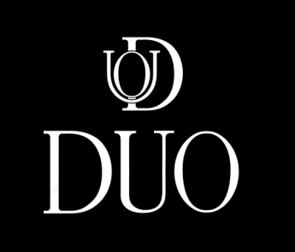

Special Dinner Menu

First Course
(choose one per person)
Seasonal Soup - prepared daily
Tuna Tartar - mango, wasabi avocado mousse
Crispy Calamari Salad - frisee, bell peppers, shaved fennel, mango, yuzu vinaigrette

Second Course
(choose one per person)
Braised Veal Osso Bucco Tortellini - spinach and ricotta cheese, hon shimeji mushrooms,
Port wine sauce
Organic Free Range Chicken Breast - chanterelle mushrooms, butternut squash, fava beans,
dried fruit chutney, thyme infused Madeira jus
Grilled Atlantic Salmon - seasonal vegetables, baby artichokes, grapes, tomato confit,
Champagne fines herbes sauce
Bordeaux Braised Short Rib and Pearls - forest mushrooms, pearl onions and pearl couscous, Gruyere fondue, rainbow baby carrots, red wine glaze

Sides
(choose one to share)
Crispy Vidalia onion rings
Sweet potato fries
Creamy spinach with Gruyere cheese
Parmesan truffle matchstick fries

Third Course
(choose one to share)
Chocolate - chocolate mousse with chocolate cake
Red Velvet - red sponge cake with cream cheese icing
Tiramisu - espresso infused vanilla cake with mascarpone cream
Raspberry - frosted raspberries on top of chocolate mousse with chocolate cake

