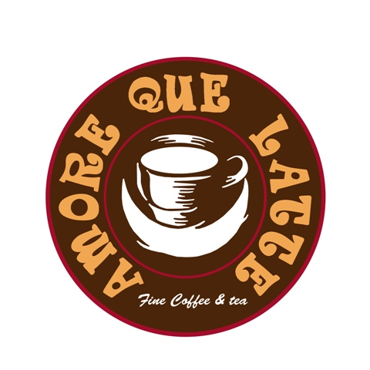
PANINI
☺ Chose between White or Wheat☺

Country
Delicious sliced Herb-Roasted Turkey with a layer of savory Muenster cheese, fresh peeled tomato, pickles and Creolla mayostard; all over a bed of aromatic organic baby greens.
8.25$

Renaissance
Angus CajunBeef with melted Swiss cheese with over a layer of Dijon mayostard, fresh peeled tomato and thin sliced sweet onions will bring freshness to this amazing panino, while gently tossed aromatic organic baby greens will add contrasting texture.
8.50$

Southern
Tender shaved Honey baked ham with natural juices, Smoked cheese, fresh peeled tomato and thin sliced sweet onions, with mayostard spread, over a bed of aromatic organic baby greens
Perfection made simple.
8.25$

Jazzy
Who would say that Turkey Pastrami is a low fat alternative to beef pastrami?
It does taste just incredible good! Let’s jazz it up with Pepper Jack cheese, refresh with some tomato, onions and aromatic organic baby greens. Mayostard spread is not forgotten.
8.25$

Fusion
Alaska smoked salmon is fused with a creamy Swiss cheese, fresh peeled tomato and aromatic organic baby greens. Dijon mayostard brings juiciness and lemon zest pepper imparts a light citrus flavor for a perfect final touch.
8,50$

Italian Blues
Genoa Salami and Muenster cheese over a layer of Pesto make it taste Italian. Fresh peeled tomato topped with a bed of aromatic organic baby greens.
Mmmmamma mia!
8.25$

Neoclassical
Shaved Oven Roasted Beef over delicious Aioli spread, Mild Cheddar cheese, Red roasted bell peppers macerated in olive oil, thinly slice sweet onions topped with aromatic organic baby greens.
Irresistible combination…
8,50$

La Bamba
The perfect combination of Shaved Oven Roasted Beef with Herb-Roasted Turkey over an amazing dry tomato pesto spread with melted Pepper Jack cheese. Fresh peeled tomato and Pickle Chips topped with Jalapeño peppers covered with aromatic organic baby greens which will explode in your mouth turning the hit up.
8,50$

Extra Virgin Olive oil is added to all Panini to intensify the flavors and make the bread crispy on the outside.
All menus come with a choice of potato chips or a yogurt

SALADS

Greek Garbanzo Bean Salad

This is a delightful salad that doesn't skimp on taste.
Baby greens, our signature garbanzo beans, sweet onion, fresh peeled baby tomatoes, black olives, Feta cheese, freshly ground black pepper, with a delicious Italian-style dressing.
6.70$

Cranberry Blue Cheese Salad

Dried cranberries mixed with baby greens are combined with Blue cheese, fresh peeled baby tomatoes, natural walnuts, black olives and croutons in this colorful and fruity salad, topped with oregano, garlic and fresh ground pepper that's sure to tantalize the taste buds.
6.70$

Greek Style Chicken Salad

Baby greens, boiled tender chicken breast meat, fresh peeled baby tomatoes, fresh cucumber, sweet onions, Feta cheese, black olives, oregano, garlic and fresh ground pepper. All we can say about this salad is YUM!
6.70$

If you don’t enjoy it tell us, if you do tell others☺
Thanks!

