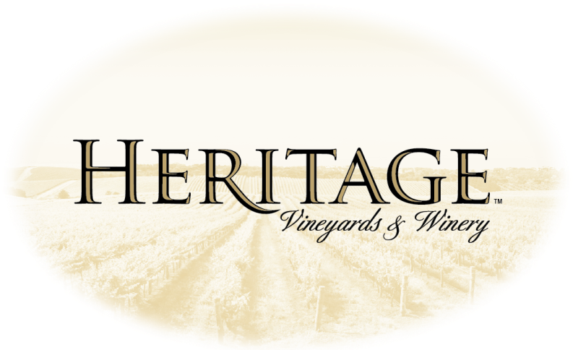
Wine by the Glass

2007 Vintner’s Reserve Chardonnay $7 Glass
* BRONZE MEDAL & 84 Pts.: WORLD WINE CHAMPIONSHIPS
Straw-almond color; subtle aromas of tangerine & ripe peach with hints of lime blossom and vanilla cream; flavors of citrus custard and toasted hazelnuts with a note of freshly ground nutmeg; this wine dances an elegant ballet on the palate, showing great balance and finesse on a graceful finish. 13.5% alc./vol.

Cuvée Blanc $6 Glass NEW RELEASE !
This cuvée of unoaked chardonnay was fermented in stainless steel & stirred for over 5 months with fine yeast lees to deepen & richen the aromas & flavors. Aromas of citrus, melon & ripe pineapple; flavors of ripe apple, lemon custard & freshly baked sugar cookies; beautifully balanced acidity focuses a long, rich finish. 12.9% alc./vol.

Red

2007 Merlot $7 Glass
*GOLD MEDAL & BEST OF CATEGORY: ATLANIC SEABOARD WINE COMPETITION
*SILVER MEDAL: FINGER LAKES INT’L COMPETITION
Aromas of black cherry and ripe strawberry with holiday evergreen wreath and fine leaf tobacco; flavors of dried cherry and toasted smoky oak; ripe but firm tannins; delicious and persistent finish. 14.0% alc./vol.

2007 Cabernet Sauvignon $7 Glass
*GOLD MEDAL: NEW JERSEY WINE COMPETITION
Crimson color; aromas of super ripe cherries, black currants, graphite and desert sage; flavors of cherry and currant fruit, with notes of pepper, eucalyptus and hewn mahogany; the bold fruit is supported by luxurious ripe tannins for an enduring finish. 14.0% alc./vol.

2008 Syrah $7 Glass

* SILVER MEDAL: FINGER LAKES INT’L COMPETITION
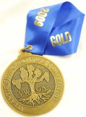
Dark-tinged scarlet color; aromas of raspberry, blueberry, dark chocolate and violets; rich flavors of purple plums, ginger, white pepper, herbs de Provence and cocoa powder; fine palate-coating tannins; rich, sustained finish. 13.5% alc./vol.

Limited Production

2008 Cabernet Franc $8 Glass
* GOLD MEDAL: GRAND HARVEST AWARDS * GOLD MEDAL: New Jersey Wine Competition

Delicate red burgundy color; aromas of black cherry and black raspberry preserves, violets, lavender and marjoram; flavors of dark cherry fruit, toasted cedar plank, vanilla and coconut, with hints of ferrous mineral and sweet peppercorns; generous ripe tannins lead to a lavish finish. 13.6% alc./vol.

2009 Chambourcin $8 Glass NEW RELEASE !
This amazingly dark, rich wine aged for 14 months in 30% NEW French oak barrels. Tasting notes: dense red-purple color; aromas of ripe, dark berry fruit and toasty oak; flavors of raspberry and cherry with hints of dark chocolate, suede leather and baked croissant; concentrated, gently tannic finish shows notes of cedar and aromatic herbs while echoing the ripe fruit.

2010 Dry Rosé $7 Glass NEW RELEASE !
This dry Rosé, produced entirely from Merlot, exhibits a lovely soft pink color, up-front strawberry & cherry fruit aromas & flavors with subtle citrus, tea & herbaceous notes. Slightly chilled, dry Rosé of Merlot is as refreshing as most white wines and as “serious” as many reds. 12.9% alc./vol.

Semi-Sweet
Jersey Red $5 Glass
Made with our own concord grapes, this wine is sweet with a lush “grapey” flavor. Sure to please even those non-red wine drinkers.
12% alc./vol.

Jersey White $5 Glass
Aromas of ripe yellow peaches & crisp red delicious apples. Flavors of fresh summer fruits, orange peel and a refreshing semi-sweet finish.
12% alc./vol.

Jersey Blush $ 5 Glass
A semi-sweet blush wine with hints of sweet plums and tart candy. Best served ice cold for a crisp and refreshing finish. 12% alc./vol.

Sweet
Apple Wine $5 Glass
You can't help thinking about fresh picked Jersey apples when you drink this wine. Experience delicious ripe apple flavors upfront with a crisp green apple finish. 9% alc./vol.

Peach Wine $5 Glass
This wine is refreshing and light with hints of peach and crisp flavors of citrus. 10% alc./vol.

