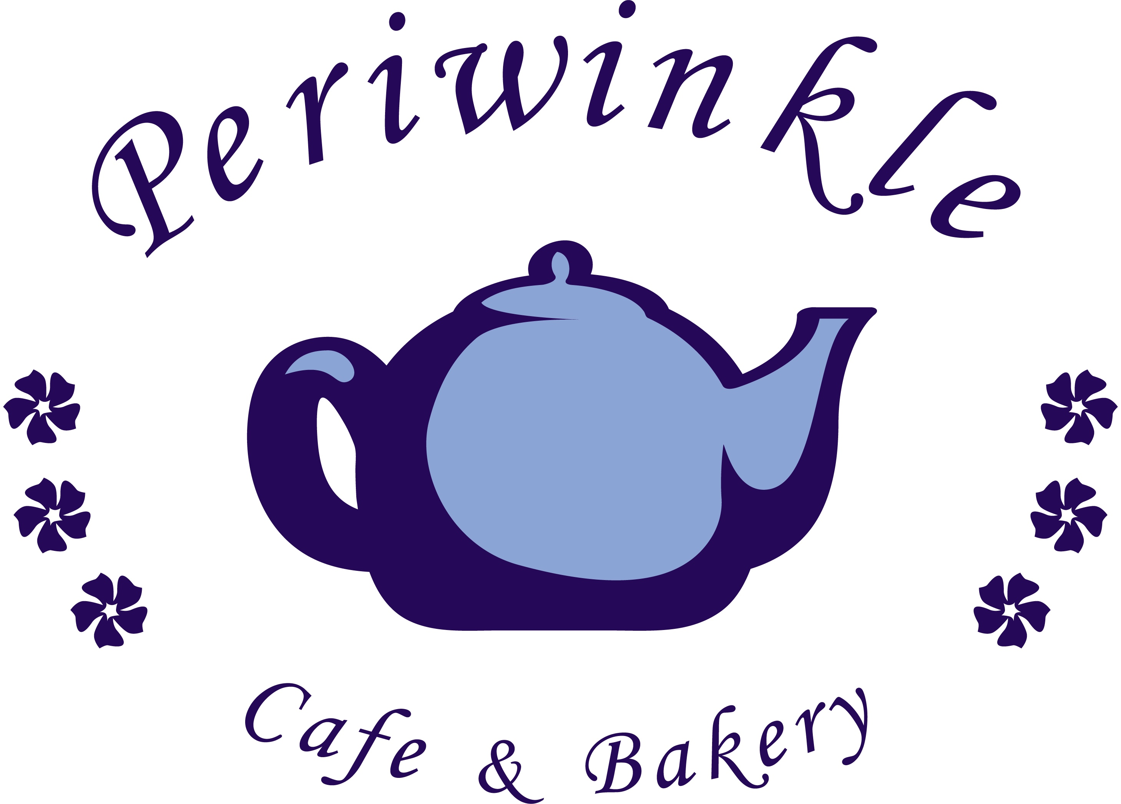

Welcome to the Periwinkle Café and Bakery. We offer fresh baked pastries, muffins, cookies, brownies and deserts. We use only quality ingredients and bake daily. Custom decorated cakes and treats are our specialty.
Stop by for breakfast or lunch and enjoy specialty coffees, espresso drinks and café style menu of soups, salads and sandwiches.
Wondering where the name Periwinkle Café & Bakery came from? Back in the 1940’s there was a building where our patio is now. It housed the Periwinkle Tea Room. It seemed a fitting tribute to a business that was similar to ours.
Located at 140 East Main Street in Old Town, Rock Hill.
Phone: 803-328-2233
Monday to Thursday 7:00 AM to 6:00 PM
Friday to Saturday 7:00 AM to 9:00 PM

Sandwiches
All of our sandwiches are served on fresh baked bread from the Bread Smith in Fort Mill, served alongside chips and a pickle.
Like your bread toasted? Just ask and we’ll toast or panini grill any sandwich.
Our goal is to please everyone. Don’t see what you like? Just ask and if we have the ingredients, we will make it to order!

Half & Half $7.49
Half of any sandwich, wrap or panini and your choice of potato salad, orzo salad, soup or fruit salad.

Turkey Pesto Panini $6.99
Oven roasted turkey breast served atop crispy romaine lettuce, provolone cheese, garlic basil pesto and mayonnaise on sourdough bread.

Roast Beef Grilled Panini $7.99
Succulent roast beef atop crispy romaine lettuce, along with provolone cheese, tomato, onion, horseradish sauce and mayonnaise on sourdough.

Marinated Portobello $5.99
Fresh Portobello mushroom marinated in balsamic vinaigrette served with provolone cheese, lettuce, onion, tomato and fresh basil on a roll.

Ham & Apple Butter $6.49
Black forest sliced ham atop crispy romaine lettuce with monterry jack cheese and an apple butter spread.

Turkey & Cranberry $5.99
Oven roasted turkey served atop crispy romaine lettuce with cranberry sauce and mayonnaise on a roll.

Bacon Lettuce Tomato $4.99
Classic BLT with crispy bacon, romaine lettuce and juicy slices of tomatoes served with mayonnaise on top of toasted sourdough bread.

Ham & Swiss $6.49
Black forest ham with crispy romaine lettuce, swiss cheese, tomato, mayonnaise and mustard. Served on multigrain bread.

Turkey & Cheese $6.49
Oven roasted turkey breast with crispy romaine lettuce, cheddar cheese, tomato, mayonnaise and mustard. Served on multigrain bread.

Tuna Salad $6.49
Fresh made tuna salad with celery and mayonnaise, served with crispy romaine lettuce and multigrain bread.

Tuna Salad by the pound $6.99

Chicken Salad Croissant $6.49
Homemade chicken salad with fresh grapes and toasted pecans served atop crispy romaine lettuce with your choice of a golden croissant or cranberry nut bread.

Chicken Salad by the pound $7.99

Club Sandwich $7.99
Oven roasted turkey, black forest ham and crunchy bacon with lettuce, juicy sliced tomato, white cheddar cheese, mayo and mustard. Served between three slices of country butter top bread.

Grilled Cheese $3.99
Classic grilled cheese sandwich with American cheese between sour dough bread slices and panini grilled golden brown.

Peanut Butter & Jelly $3.50
Classic PB & J with your choice of crunchy or smooth peanut butter with strawberry jelly in between two slices of country buttertop bread.

Peanut Butter & Banana $3.50
Choice of crunchy or smooth peanut butter served with banana slices in between country buttertop bread.

Wraps
Your choice of a soft lavish or honey wheat wrap, served with chips and a pickle spear. Served as is or grilled on the panini grill.

Veggie Wrap $5.49
Mediterranean hummus with cucumbers, tomato, green pepper, red onion, romaine lettuce, avocado and roasted red pepper.
Add cheese for $0.50 and add meat for $2.49.

Ham Wrap $6.99
Black forest ham with white cheddar cheese, romaine lettuce, tomato and garlic cream cheese spread.

Turkey Wrap $7.49
Oven roasted turkey with monterey jack cheese, romaine lettuce, tomato, fresh basil and garlic cream cheese spread.

Chicken Wrap $7.49
Baked chicken with bacon, shredded cheddar, romaine lettuce, tomato and honey mustard.

Salads
All of our salads are made with crispy romaine and spring mix. Served with your choice of dressing and a fresh yeast roll.

Garden Salad $3.99
Cucumbers, tomatoes, red onion, green peppers, carrots, mushrooms, and shredded cheddar cheese.

3 Salad Salad $7.49
Scoops of our homemade chicken salad, tuna salad, and fruit salad piled on a bed of greens. Served with a side of lime yogurt dressing.

Chef Salad $7.99
Black forest ham, oven roasted turkey, sliced roast beef and tomato, cucumber, onion, green pepper, mushrooms and cheddar cheese.
Chicken Cobb Salad $7.99
Slow baked and marinated chicken breast, bacon crumbles, cucumbers, tomatoes, sliced eggs, french onions and shredded cheddar cheese.

Greek Salad $6.99
Black olives, artichokes, roasted red pepper, feta cheese, red onion and tomatoes.

Periwinkle Salad $5.99
A fresh combination of mandarin oranges, toasted pecans, craisins, feta cheese, apple slices and carrots.

Add Chicken to any Salad $2.49
Dressings
House Dressing: Grape Seed Vinaigrette from Brick Village Gourmet in Western New York
Ranch * Fat Free Ranch * Bleu Cheese * Italian * Poppy Seed * Honey Mustard * French * Balsamic Vinaigrette

Sides
Fruit Salad $3.50
A blend of seasonal fruit with lime yogurt dressing.

Orzo Pasta Salad $3.50 Orzo pasta with wild rice and a colorful medley of corn, craisins, cilantro and green pepper with special light dressing. By the pound $5.99
Soups
Soup Du Jour $4.99
Homemade Potato Salad $3.50
Red skin potatoes, celery, mayonnaise onion, and our special seasoning. By the pound 5.99.

Substitute chips and a pickle on a meal with any above side for $1.99.

A 12 oz bowl of our specialty made soup of the day
with a fresh baked yeast roll

Breakfast
Our breakfast is light and delicious. Check with us often as our offerings change as we try new recipes. You never know what we will be serving up in the morning.
Fruit Cup $3.50
With lime yogurt dressing.

Yogurt Parfait $3.75
With granola and fruit.

Plain Bagel or Biscuit $0.95

With Egg & Cheese $2.19

With Egg, Cheese and Meat $3.19
Meat choices include ham, bacon or sausage

Bagel with Cream Cheese $1.95
Plain, Low Fat, Strawberry or Honey Walnut

Bagel, Toast or Biscuit $1.50
With peanut butter, apple butter, honey or jelly

Upgrade to a Croissant add $0.50

Assorted Pasteries
We have a fresh assortment of pastries daily. Check out our pastry case to see what we baked fresh for you today.

Café

Our coffee is locally roasted and organic. Periwinkle Blend is a smooth, rich blend. Periwinkle blend is a smooth medium roast. Each day we will feature a flavored coffee drink.
Hot Drinks Iced Drinks All 16 oz
Brewed Coffee S $1.75 M $1.95 L $2.10 Iced Coffee $2.25
Mocha S $3.35 M $3.75 L $3.95 Iced Latte $3.15
White Mocha S $3.60 M $4.00 L $4.20 Iced Mocha $3.75
Cappuccino S $2.75 M $3.15 L $3.70 Iced White Mocha $4.00
Latte S $2.75 M $3.15 L $3.70 Iced Chai or Chai Latte $3.25
Hot Chocolate S $2.25 M $2.50 L $2.65
Caramel Latte S $3.35 M $3.75 L $3.95 Blended Drinks All 16 oz
Chai S $2.85 M $3.25 L $3.75 Café Blender $3.75
Chai Latte S $2.85 M $3.25 L $3.75 Mocha Blender $3.95
Hot Mighty Leaf Whole Leaf Tea S $1.75 White Mocha Blender $3.95
Caramel Blender $3.95
Other Drinks Fruit Blender $3.95
Bottled Soda or Water $1.50
Fountain Soda $1.75
Iced Tea $1.75

